Nkhensile Mthombeni

ST10477539

POE PART 2 MAST5112

# Introduction

The Christoffel Menu App is a simple mobile application developed using React Native and Expo. It allows Chef Christoffel, a private chef, to manage his daily menu by adding, viewing, editing, and deleting dishes. The app works on both Android and iOS devices and provides a clear and simple way to manage food items, their descriptions, and prices.

# 2. Purpose of the App

The main goal of the app is to help Chef Christoffel organize his menu items easily. The app replaces paper menus by storing dish information digitally. Users can add new dishes, update prices or descriptions, and remove dishes that are no longer available. It also supports search and filtering by course (Starter, Main, Dessert) for convenience.

# 3. Screen Descriptions

## 3.1 Menu List / Dashboard

This screen displays all the dishes in a list format. Each dish is shown in a card with its name, short description, and price. A search bar and filter buttons help users find specific dishes easily. The '+ Add' button allows navigation to the Add Item screen.

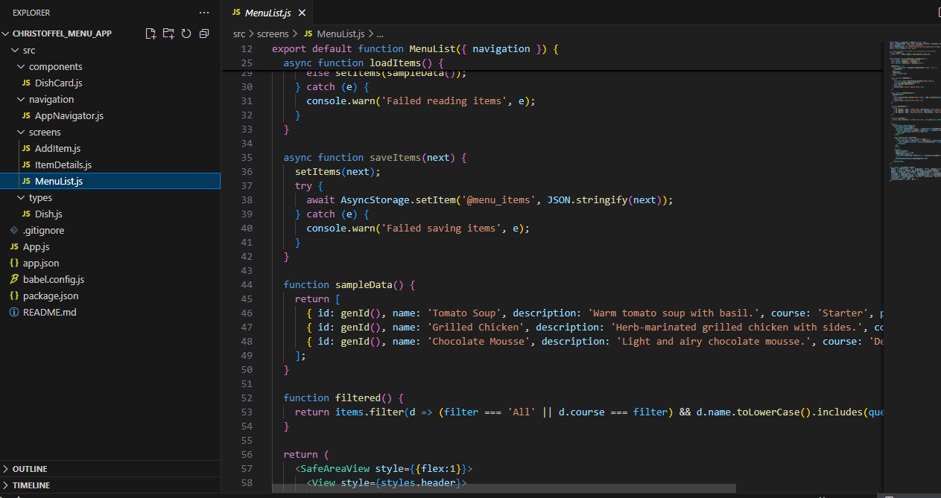

# 3.2 Add / Edit Menu Item

The Add / Edit screen lets users add a new dish or update an existing one. It includes text fields for the dish name, description, course, and price. When the Save button is pressed, the dish is saved locally using AsyncStorage, while the Cancel button takes the user back to the Menu List screen.

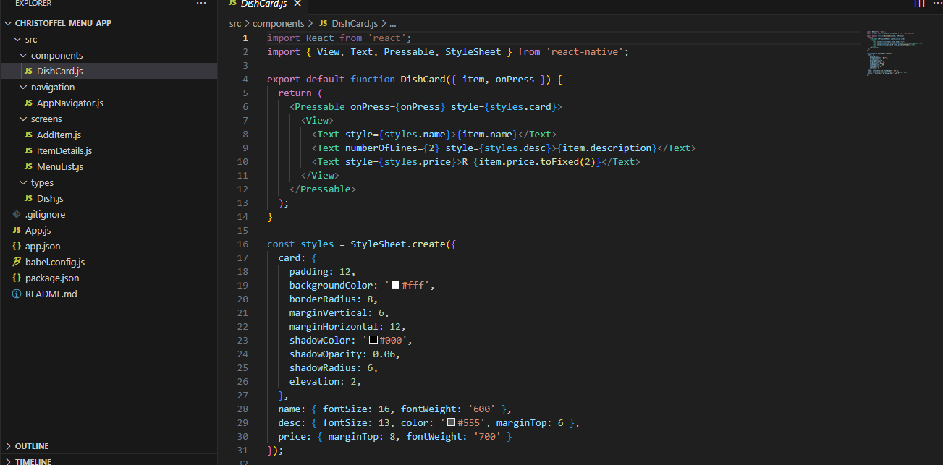

# 3.3 Item Details

This screen displays detailed information about a specific dish. It includes the dish’s name, course, price, and description. Users can edit or delete the item from this screen. This makes managing menu items simple and efficient.

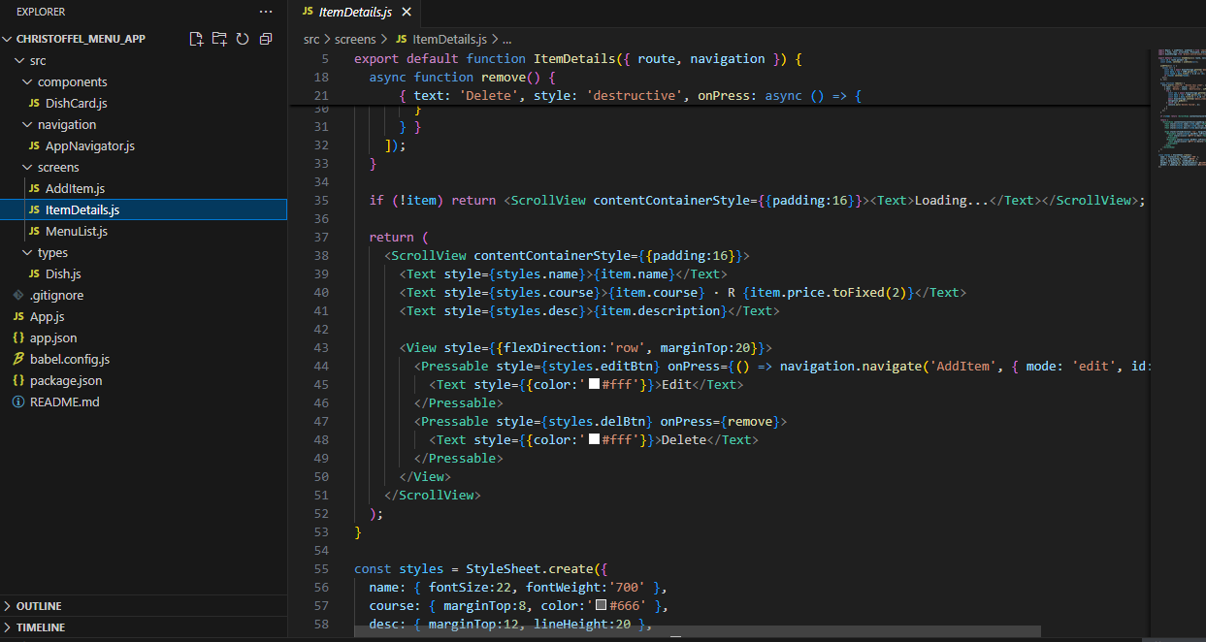

# 4. Navigation Flow

The app uses React Navigation’s Stack Navigator to move between screens. The navigation starts at the Menu List screen, where users can go to Add Item or Item Details. From the Item Details screen, users can edit or delete an item. The flow is designed to be easy and intuitive for all users.

# 5. Implementation Summary

The Christoffel Menu App is built using React Native with Expo for cross-platform compatibility. It uses functional components and React Hooks (useState, useEffect) for state management. AsyncStorage is used to store data locally, ensuring the user’s menu items remain saved even after restarting the app. React Navigation handles transitions between screens, while StyleSheet provides consistent design and layout.

# 6. Conclusion

In conclusion, the Christoffel Menu App is an effective and easy-to-use solution for managing dishes. It covers key mobile development practices such as navigation, data storage, and form handling. Even without a backend server, it performs all core menu management tasks smoothly, making it ideal for Chef Christoffel’s business needs.